Astro 331

Space Systems Engineering


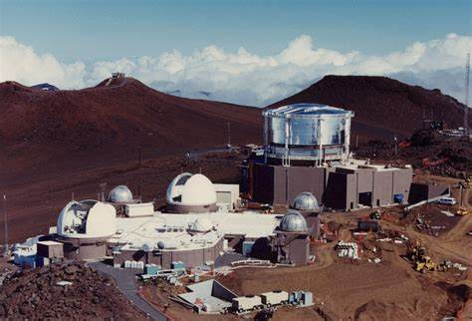
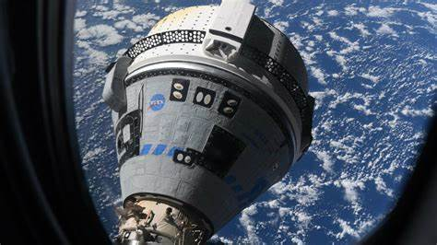
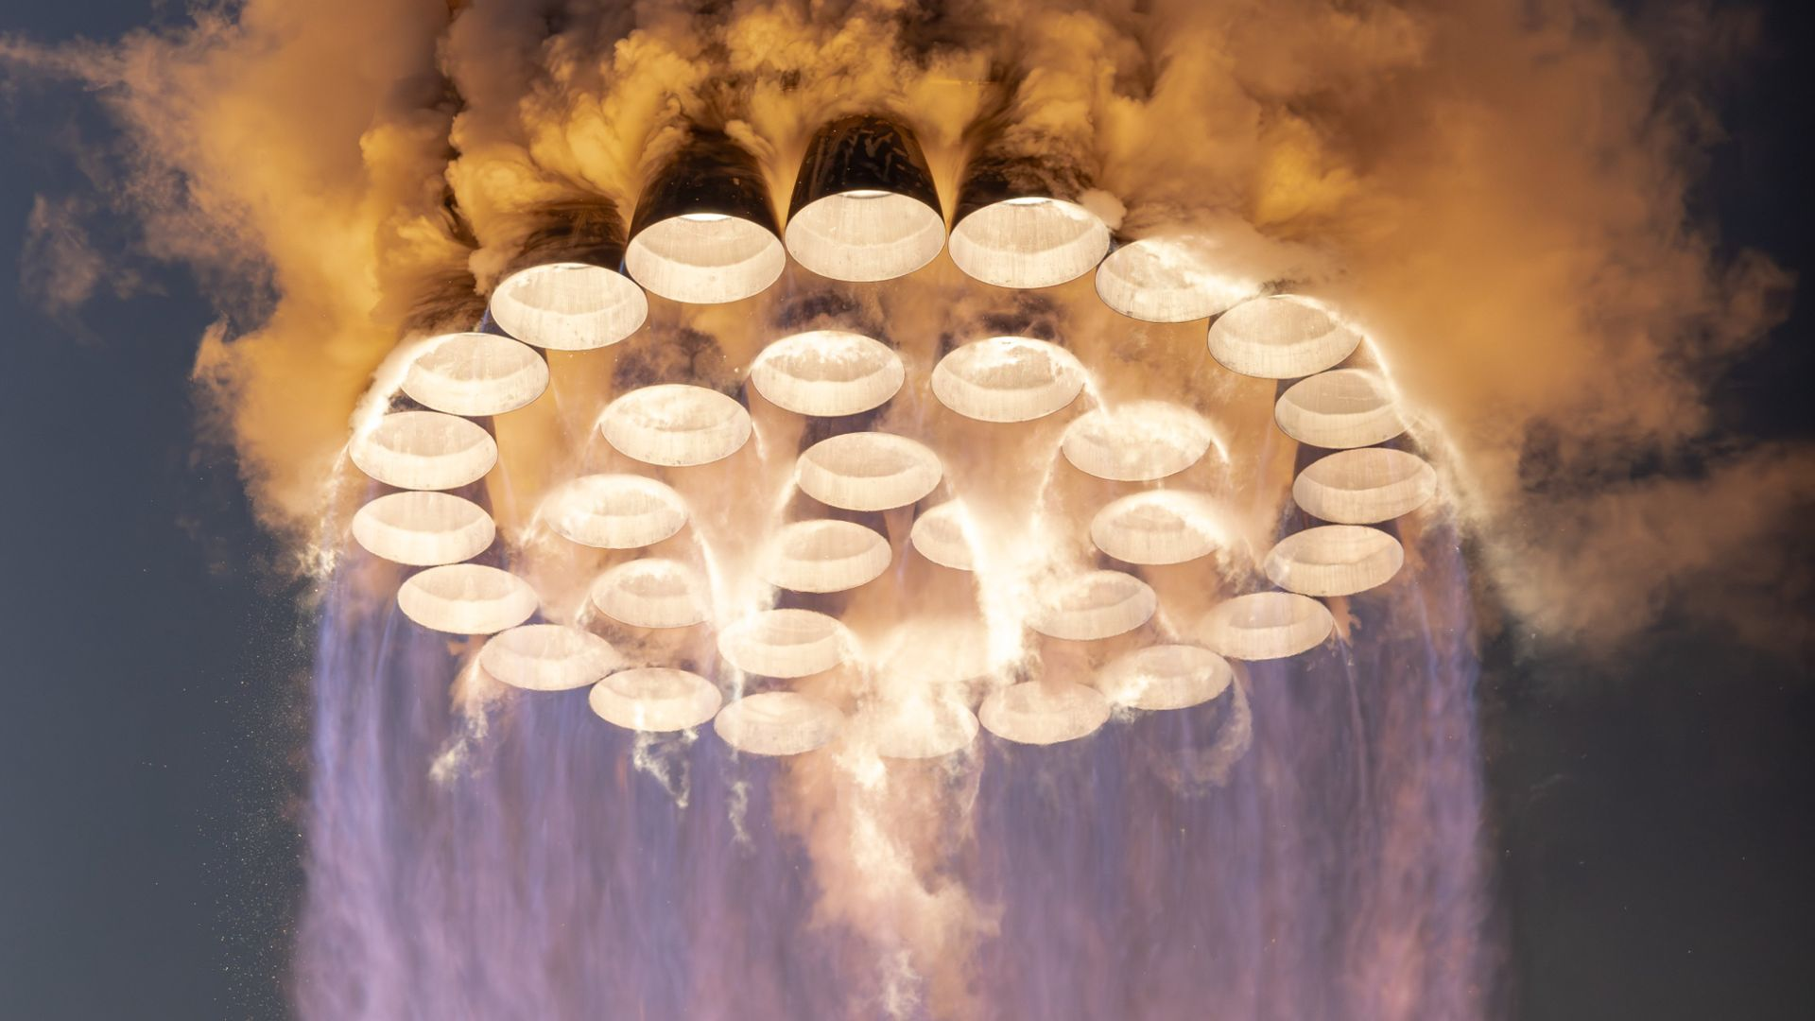
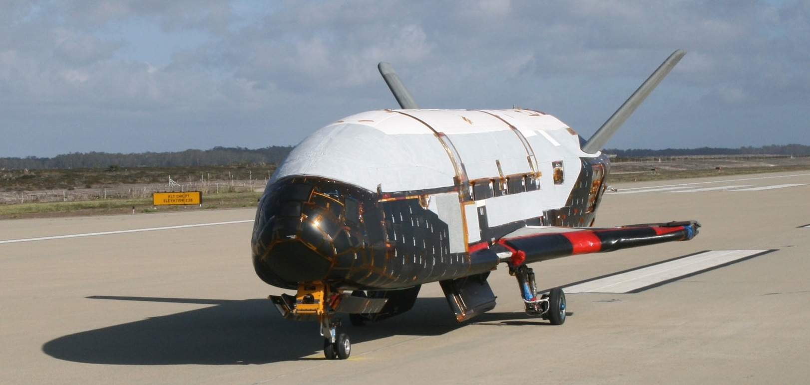
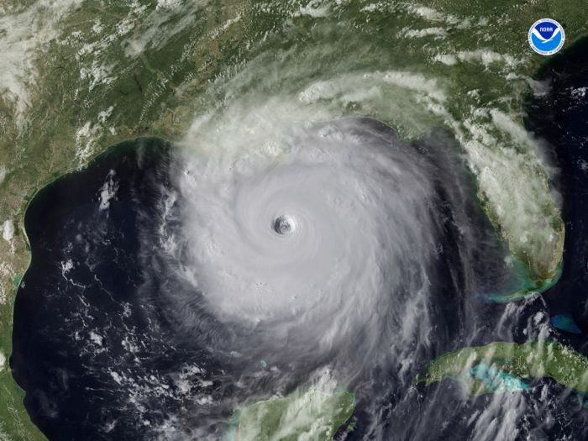


Fall 2025

CADET HANDBOOK

DEPARTMENT OF THE AIR FORCE
The Department of Astronautics
USAF Academy, Colorado



10 December 2025
MEMORANDUM FOR All Cadets Enrolled in DFAS Courses

FROM: HQ USAFA/DFAS

SUBJECT: Department Course Policies

1. Welcome to Astro, the ultimate high ground! All Astro courses prepare you to leverage space assets and resources to lead and prevail in conflict. These courses emphasize the essential skills of problem solving and quantitative literacy within the warfighting domain of space.
2. Class Preparation: We believe the keys to learning are preparation, involvement, and practice. It’s your responsibility—part of your duty—to come to class prepared to participate in your education by reading the day’s assignment and making a sincere effort to complete any homework that is assigned.
3. Testing and Grading:
a. If you think you may miss an upcoming graded event, coordinate with your instructor ASAP. If you miss an exam without prior coordination, you will receive a mandatory academic penalty of 25%. Cadets arriving less than 15 minutes late for a GR or less than one hour late for a final (in both cases, unexcused) will immediately begin the exam and finish with the rest of the class.
b. If you have a medical issue that would impact your performance on an exam, you must let your instructor know PRIOR to the exam. If you choose to start an exam this constitutes an understanding that you will receive the grade earned for that exam, regardless of any extenuating circumstances. You will not have the opportunity to retake an exam once you have taken it for a grade.
c. You must earn at least 60% of all points available on individual graded events in order to pass most Astronautics courses.
d. No major exams will be administered virtually or on the road. You are expected to make every effort to complete your exam beforehand if you are unable to make the test date.
e. During exams, you may use your calculator for computations only—not as a platform to automate solutions or regurgitate saved material.
4. Projects, Labs & Homework:
a. Graded work turned in up to 24 hours late will receive a 50% penalty. Graded work turned in more than 24 hours late earns 0%. (Note: 24 hours after Friday is Saturday.) All graded course work should be accomplished even if it is past the 24 hour deadline—failure to do so may result in a controllable incomplete (IC) grade.
b. Unless otherwise specified by your instructor, all graded work is due at the beginning of your class period. Due dates for all graded work will be clearly identified in the course syllabus, and project/lab descriptions are provided in the course documentation.
c. Meeting with an instructor outside of class is a professional courtesy. Extra instruction (EI) is encouraged and available from any department instructor. Instructors aim to be available during the Advising/EI period on T-days from 1230–1323. Outside this time, please schedule an appointment to ensure availability. Contact instructors only during regular duty hours, and never after 1700 unless it’s an emergency. Always seek help from your own instructor first; if unavailable, you may approach another DFAS instructor. Instructors are not expected to respond to EI requests on weekends or after hours.
5. Lab Locations: The Space Systems Research Center is located on the first floor (southeast corner) of Gregory Hall and is available to trained personnel. The small-satellite and controls labs are located in room 5J21 on the fifth floor (near the southeast stairwell) of Fairchild. Each of these facilities require instructor approval for access.
6. Documentation: All graded work is individual effort unless joint effort is specifically authorized. Each graded assignment will clearly define authorized joint effort. When in doubt, always assume individual effort and ask your instructor for clarification. Document all sources of help on all graded work, including proof reading. Your documentation must clearly identify what ideas, words, and data are yours and what are attributed to other sources. If you did not receive any help on a graded homework or report, then you must write “DOCUMENTATION: NONE” on your documentation page. If you submit work without proper documentation, it will be returned to you for resubmittal with corrected documentation, and you will receive a 5% deduction.
7. Generative Artificial Intelligence (AI): The use of generative AI to accomplish or assist in accomplishment of graded work is allowable in courses offered by the Department of Astronautics. However, course directors and instructors in the Department may choose to limit or prohibit AI for their course or any assignment. You are accountable for any AI generated work you submit. The use of AI is also subject to the following conditions:
a. Any use of generative AI must be thoroughly documented per the documentation standards above. Documentation must include a digitally delivered link to the chat discussion including all prompt and outputs. At a minimum students will identify specific exercises, problems, answers, or concepts that were influenced by AI.
b. Your instructor reserves the right to award zero credit to AI generated answers, work, or assignments that are incorrect and/or demonstrate a lack of comprehension and/or effort. Simply copying an AI response is unacceptable as turned-in work.
8. Class Attendance: Class is a military formation just like any briefing, parade, or meeting with a senior officer. Exceptions and excusals for classes are rare and only allowed as determined by USAFA Instruction 3536 Attachment 3: Order of Precedence, unless a specifically approved SCA is presented.
a. All SCA-approved absences require either instructor “approval” or “coordination. You must personally contact your instructor prior to missing class as far in advance as possible. Last minute, or after-the-fact, e-mail notifications are unacceptable and will be marked as unexcused. Cadets missing more than eight classes in a semester are required to meet with the department head. Cadets missing more than 10 classes will be carefully reviewed and removal from the class is probable.
b. We expect you to arrive at class on time. A Form 10 will be issued for all unexcused tardies and absences. It is your responsibility to communicate with your instructor if IT disruptions hinder your ability to access classes and material.
c. Class disruptions will not be tolerated. You must be in the classroom at the official start of class, not in the restroom, and be in the proper uniform or you will be marked as absent or tardy. Extra instruction will not be given for material missed due to a voluntary or unexcused absence.
d. Laptops and tablets may be used in class only for note-taking and accessing reference materials.
e. Cell phone use during class is strictly prohibited unless specifically authorized by your instructor for specific events.
9. These policies are meant to encourage professional performance, reward success, and foster a positive interaction between you and your Astro instructor. If you have any questions about these policies, please discuss them with your instructor, the course director, or me. Best wishes for a great semester!

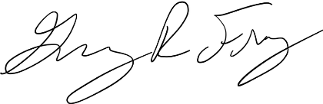

GREGORY R. FREY, Lt Col, USAF
Head, Department of Astronautics

INTRODUCTION

Fundamentals of space vehicle design are presented with an emphasis on systems engineering. Introduction to system-level spacecraft design issues are covered including reliability, environments, radiation effects, testing, materials engineering, integration, launch vehicles, and operations. Introduction to and analyses of payloads, structures, propulsion, electrical power, communications and data handling, attitude determination and control, and thermal control subsystems are also covered. The course includes an integrated lab experience where small teams develop, analyze, and integrate subsystems into a functioning engineering model satellite. Each team demonstrates and documents their engineering model satellite at the system level as a part of a laboratory report.

GOALS

- To build on your knowledge of basic astronautical, electrical, and mechanical engineering disciplines to increase your level of understanding and design proficiency of spacecraft payloads and subsystems.

- To understand system-level spacecraft design issues and to reinforce learning through a practical small-satellite laboratory experience.

OUTCOMES

- Each student will understand system-level spacecraft design issues to include: mission astrodynamics, reliability, space environment, radiation effects, testing, materials engineering, integration, launch vehicles, and operations.

- Each student will be able to discuss influences to designing subsystems and/or analysis of subsystems to include: structures, propulsion, electrical power, communications, command and data handling, attitude determination and control, and thermal control.

- Each student will be able to apply their payload, subsystem, and system level understanding to a laboratory experience where they will first demonstrate a payload and subsystems and perform data analysis on their results and correlate that to their predictions based on subsystem design covered in class.

RESOURCES

- Course Text: Introduction to Mission and Spacecraft Design by Scott Dahlke
  - PDF provided in course Teams folder
  - Additional supplementary course readings will be provided throughout the semester

GRADING

Event | Final Percentage
Skills Review* | 4%
Homework | 8%
GR #1* | 12%
Pre/Post-Labs (4 total)* | 8% (2% each)
GR #2* | 12%
Lab 1 Turn-in and Quiz* | 5%
Lab Reports (2 total) | 12% (6% each)
Lab 8 Presentation | 14%
Final Exam* | 25%
* Denotes individual effort

Individual Effort
Per DFAS policy, cadets must score above 60% avg. on Individual Effort graded events.

Graded Events Descriptions
- Skills Review
  - Individual Effort
  - GenAI Level 0 (No use of GenAI)
  - Use Understanding Space as your primary reference. You are authorized to use any of your own notes from Astro 310 to complete this assignment, but no other resources are authorized.

- Homework
  - GenAI Level 3 (Use of GenAI as a feedback tool on student-generated work)
  - Each cadet will submit their own homework problems. Show all work.
  - Homework is open resource (notes, textbooks, websites, etc.) EXCEPT any cadets who have already taken Astro 331. Collaboration with other cadets currently enrolled in Astro 331 is both authorized and encouraged. However, each cadet must perform and submit their own work. You may not work together and simply print two copies.

- GR #1 & GR #2
  - Individual Effort
  - GenAI Level 0 (No use of GenAI)
  - Closed book; calculator
  - equation sheet
    - GR #1: 1 side of 8.5” x 11” HAND WRITTEN self-made notes
    - GR #2: 1 side of 8.5” x 11” HAND WRITTEN self-made notes

- Pre/Post-labs (4 total)
  - Individual Effort
  - GenAI Level 3 (Use of GenAI as a feedback tool on student-generated work)
  - Explanation of process and prediction/analysis of expected/actual lab results.
  - Pre/Post-labs are open resources (notes, textbooks, websites, etc) EXCEPT any other cadets/students/persons (instructor EI ok). You may not discuss a pre/post-lab with any other cadet until it is returned to you by your instructor. Any resources used must be properly documented.

- Lab 1 Turn-In
  - Individual Effort
  - GenAI Level 4 (Use of GenAI to co-create and/or revise work)
  - Lab 1 is open resources (notes, textbooks, websites, etc) EXCEPT any other cadets/students/persons (instructor EI ok). Any resources used must be properly documented.

- Lab 1 Quiz
  - Individual Effort
  - GenAI Level 0 (No use of GenAI)
  - Closed book
  - Lab 1 Quiz is an in-class assessment of Lab 1 content.

- Lab Reports (2 total)
  - GenAI Level 3 (Use of GenAI as a feedback tool on student-generated work)
  - A group report that covers lab results. A template is provided.
  - Each lab team submits one lab report, following the DFAS Writing Guide short report template. Length should be no more than 15 pages, not including appendices.
  - You are authorized open resources (notes, textbooks, websites, etc) EXCEPT any other cadets/students/persons who are not on your lab team (instructor EI ok). You are encouraged to use any of your team members’ prelab work as part of this report. Any resources used must be properly documented.

- Lab 8 Presentation
  - GenAI Level 4 (Use of GenAI to co-create and/or revise work)
  - A 20-minute group presentation that covers lab 8 process and results.
  - Presentation guidance provided.
  - You are authorized open resources (notes, textbooks, websites, etc) EXCEPT any other cadets/students/persons who are not on your lab team (instructor EI ok). You are encouraged to use any of your team members’ previous lab work as part of this project. Any resources used must be properly documented.

- Final Exam
  - Individual Effort
  - GenAI Level 0 (No use of GenAI)
  - Closed book; calculator
  - equation sheet
    - Two (one-sided) 8.5x11” HAND WRITTEN self-made notes

Grade Lines

A | A- | B+ | B | B- | C+ | C | C- | D | F
90% | 87% | 83% | 80% | 77% | 73% | 70% | 67% | 60% | <60%

ADDITIONAL INFORMATION

Instructor contact info:
INSTRUCTOR | Room | Office Phone | Cell Phone
Lt Col Wyatt Harris | 6H-149 | 333-6180 | (520) 730-0072

Extra Instruction
  - Please schedule EI during normal business hours if possible.
  - Have an agenda (specific questions, etc.) when you schedule EI.

Please ensure that you understand this policy letter, as well as the department policy letter. If you have any questions, check with your instructor. Our primary duty is to help you become the finest Air and Space Force officers in the world who live the core values and learn space by doing space!
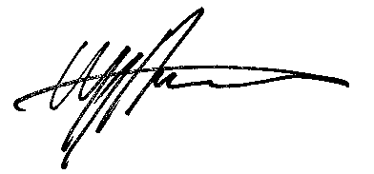

WYATT J. HARRIS, Lt Col, USSF
Astro 331 Course Director

